# What is a Variable in Python?

A Python variable is a reserved memory location to store values. In other words, a variable in a python program gives data to the computer for processing.

Every value in Python has a datatype. Different data types in Python are Numbers, List, Tuple, Strings, Dictionary, etc. Variables can be declared by any name or even alphabets like a, aa, abc, etc

# Variable Naming Rules in Python

1. Variable name should start with letter(a-zA-Z) or underscore (_).

Valid :age , _age , Age

Invalid : 1age

1. In variable name, no special characters allowed other than underscore (_).

Valid :age_ , _age

Invalid : age_*

1. Variables are case sensitive.

age and Age are different, since variable names are case sensitive.

4.Variable name can have numbers but not at the beginning.

Example: Age1

5.Variable name should not be a Python keyword.Keywords are also called as reserved words.

Example

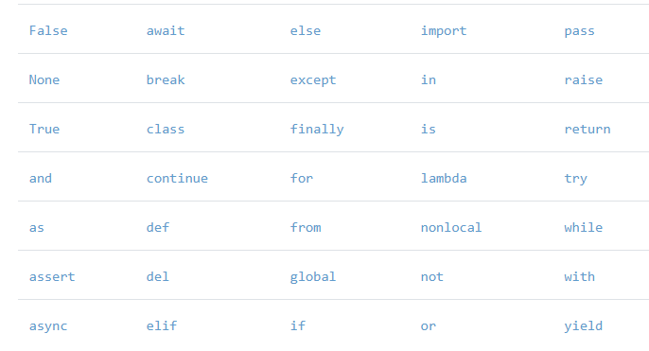

# How to Declare and use a Variable

Let see an example. We will declare variable "a" and print it.

a=100

print (a)

Re-declare a Variable

You can re-declare the variable even after you have declared it once.

Concatenate Variables

a=100

print(a)

a=’AECS Jaduguda’ print(a)

a='AECS'

b=1 print(a+b)

will throw error , as we cannot concatenate two different datatypes. But a='AECS'

b=1 print(a+str(b)) will display AECS1

# Delete a variable

You can also delete variable using the command **del** "variable name".

The below table displays the list of available assignment operators in Python language.

1. What are keywords in python

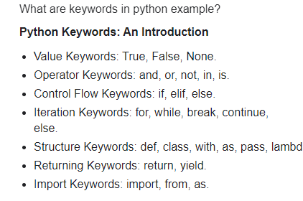

1. What are in-built unctions – 68 types nearly

The Python built-in functions are defined as **the functions whose functionality is pre-defined in Python**. The python interpreter has several functions that are always present for use. These functions are known as Built-in Functions.

<https://www.w3schools.com/python/python_ref_functions.asp>

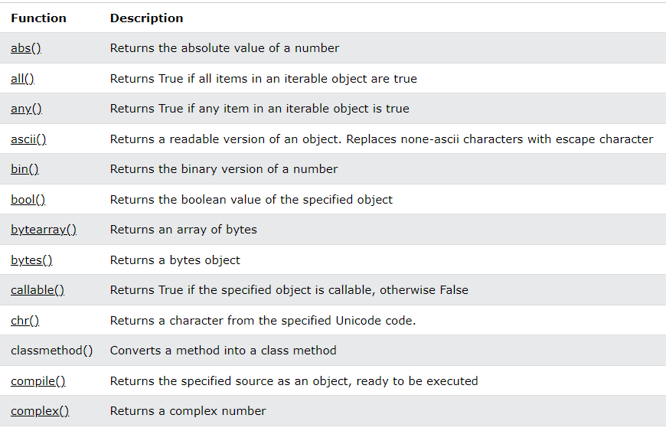

1. Data types in python

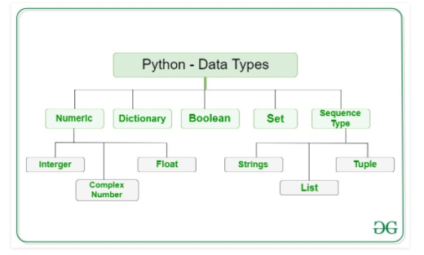

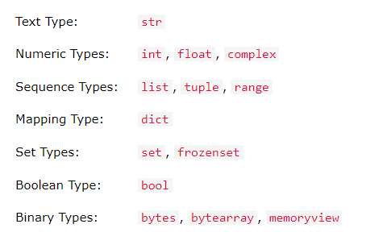

1. Data structures in python

Data structures are **a way of organizing and storing data so** that they can be accessed and worked with efficiently. They define the relationship between the data, and the operations that can be performed on the data.

There are **four** built-in data structures in Python - list, tuple, dictionary and set.

1. Operators in python

Python divides the operators in the following groups:

* Arithmetic operators
* Assignment operators
* Comparison operators
* Logical operators
* Identity operators
* Membership operators
* Bitwise operators

7.What are functions in python

In computer programming, a function is a named section of a code that performs a specific task. This typically involves **taking some input, manipulating the input and returning an output**.

Or

A Function in Python is a **piece of code which runs when it is referenced**. It is used to utilize the code in more than one place in a program. It is also called method or procedure. Python provides many inbuilt functions like print(), input(), compile(), exec(), etc.